Name: Shriharsh Vinod Patil

PRN:2019BTEIT00070

Batch: B-4

# 1. Study and use different graphs and charts (use MS-XLS).

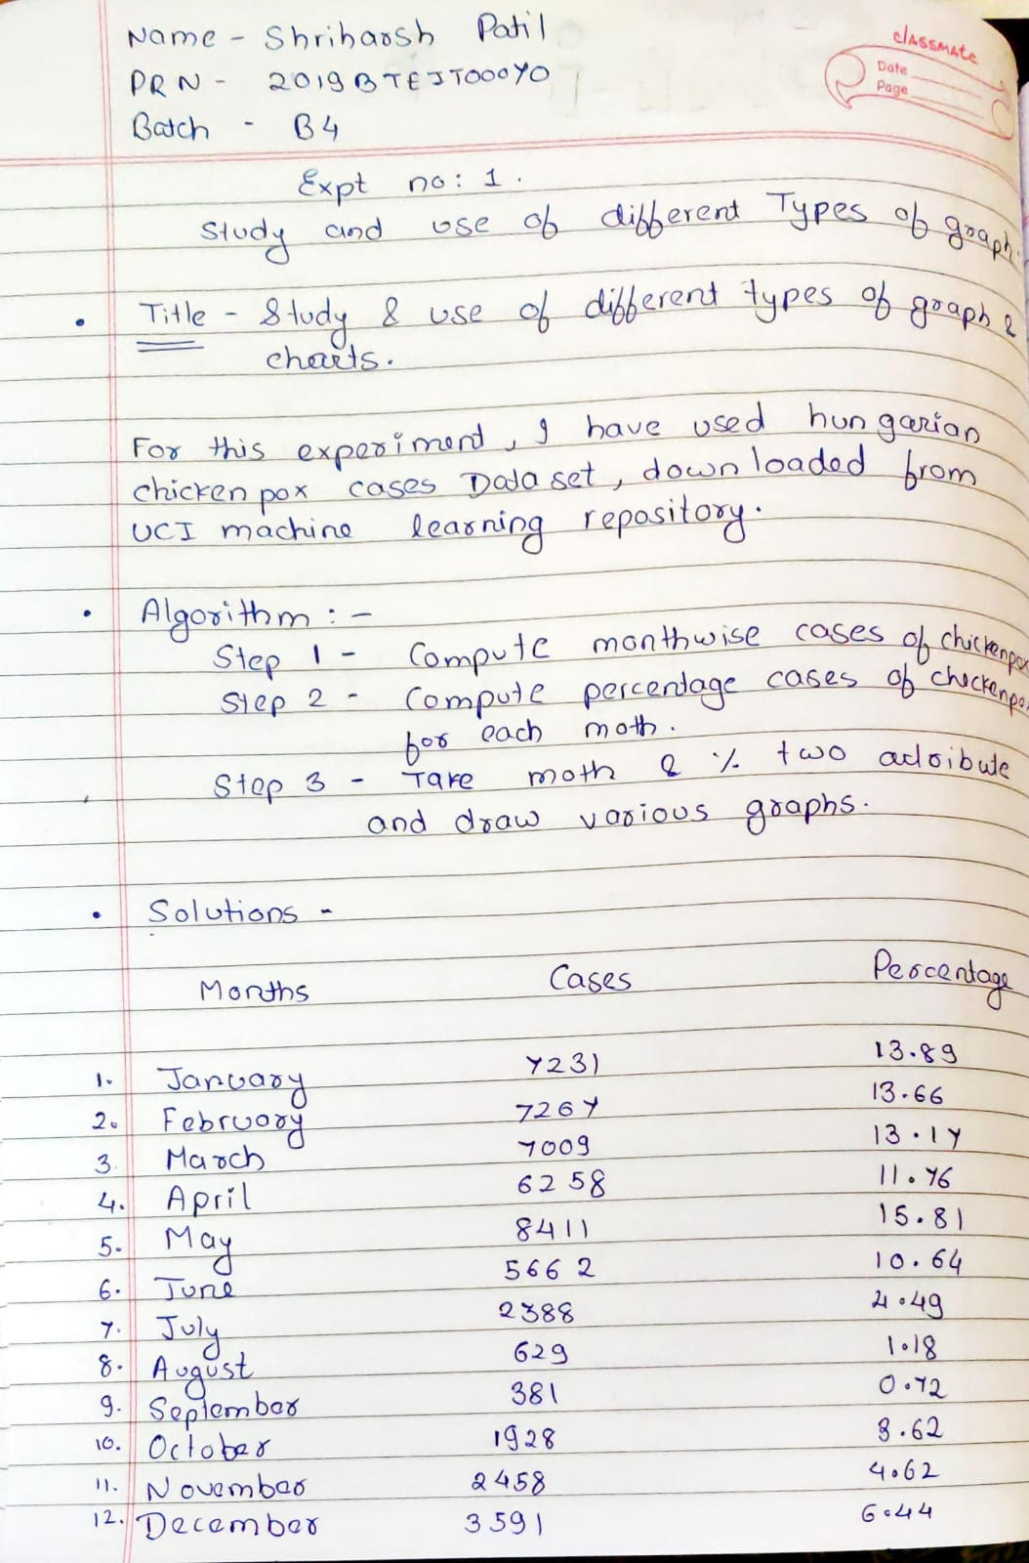

**Data set(Hungarian Chickenpox Cases Data Set)**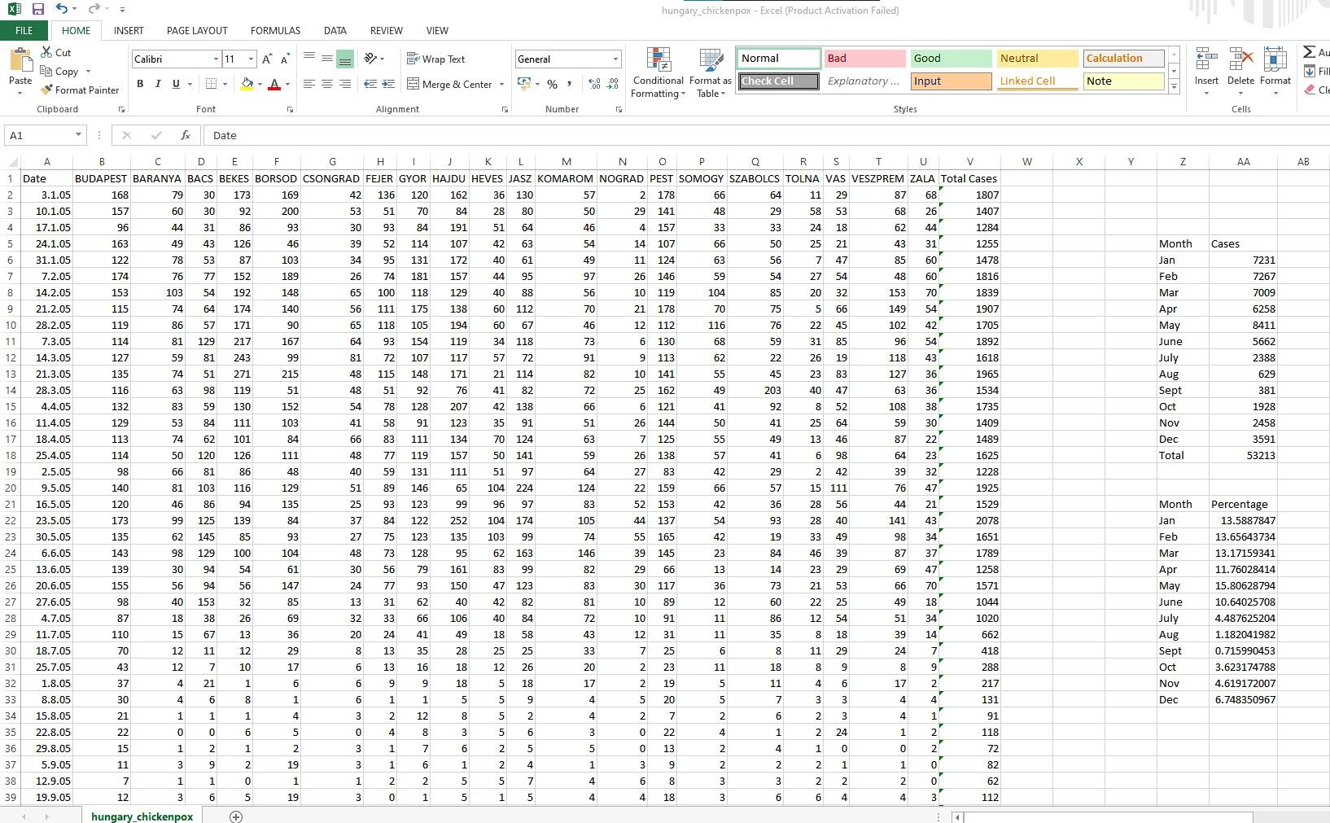

**Output:**

**Pie chart**

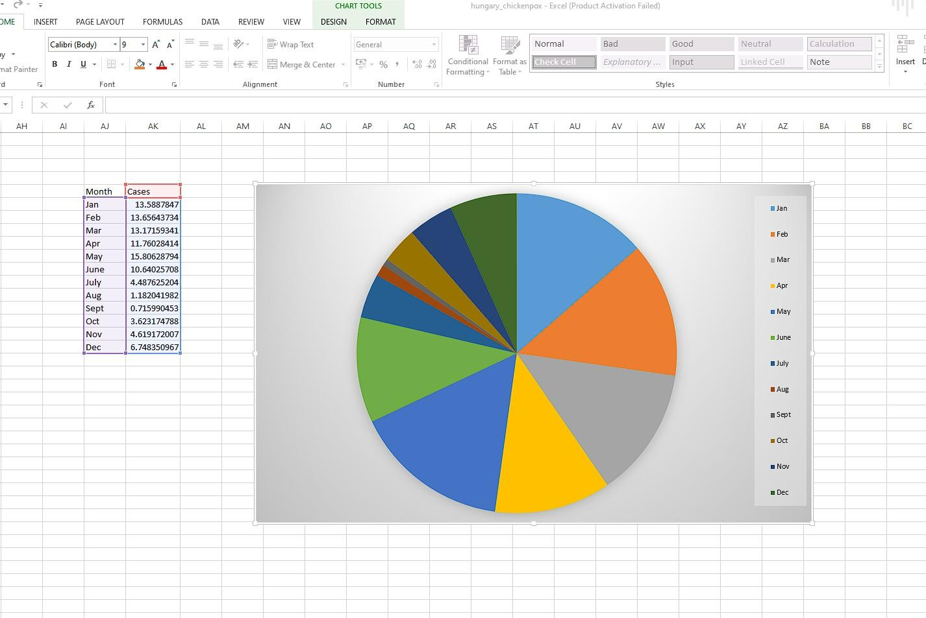

**Bar chart**

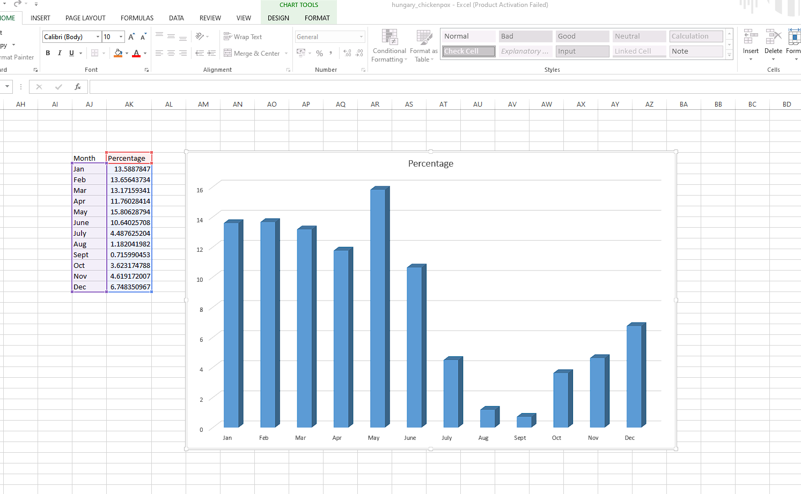

**Conclusion:**

By using the Hungarian Chickenpox Cases dataset provided by the UCI machine learning repository, I was able to understand the various graphs, and charts. I also drew a diagram for a vast data set by performing some calculations.

**Experiment 2**: Perform Normalization of data (Min-max and Z-score).

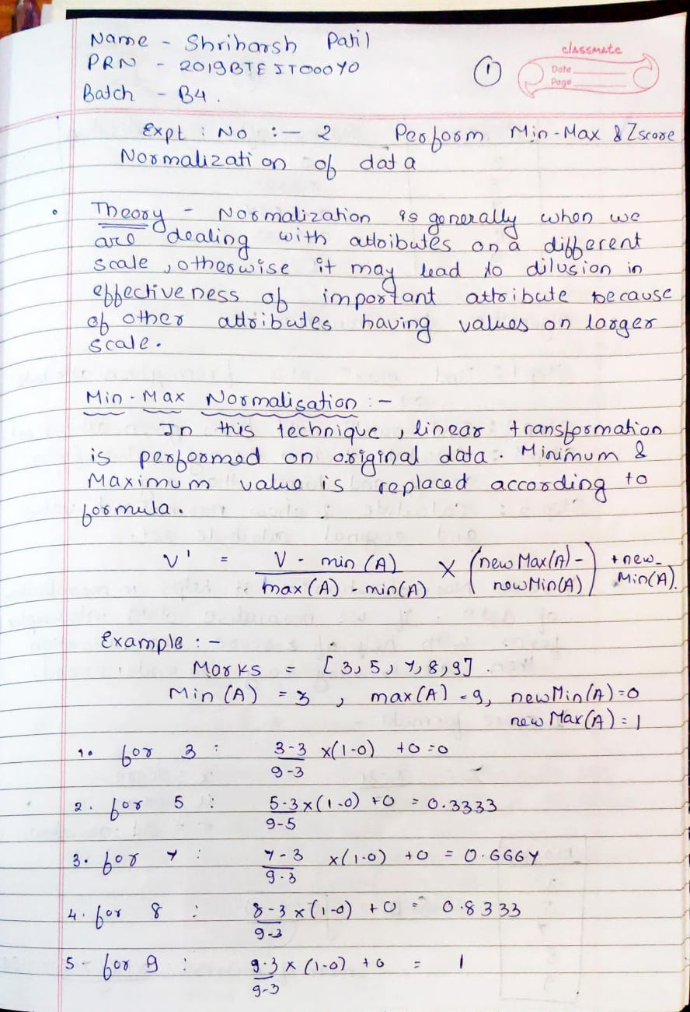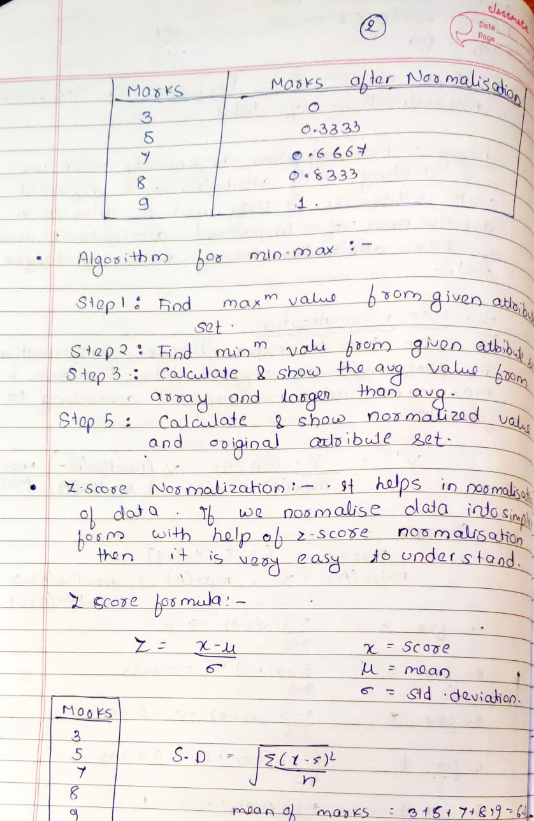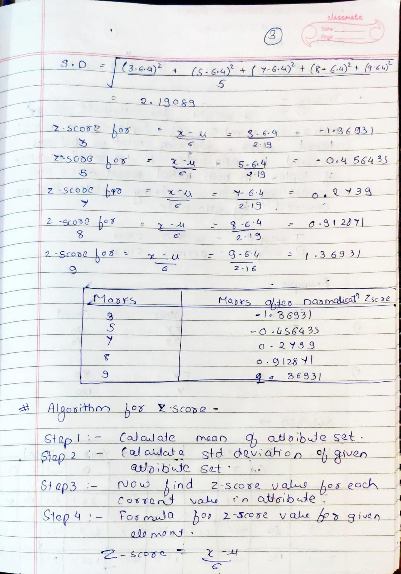

# CODE :

from cmath import sqrt

import pandas

import math

import csv

# reading the CSV file

csvFile = pandas.read_csv('Normalization_Input.csv')

#Storing all elements in Array

arr = []

for row in csvFile:

arr.append(int(row)) #Type casting to integer as CSV gives files in String format

n = len(arr) #length of Array

sum_array = sum(arr) #Sum of all elements in Array

mean_array = sum_array/n #Mean of Array

max_array = max(arr) #Max of all elements in Array

min_array = min(arr) #Min of all elements in Array

MinMaxNorm = []

for i in arr:

tmp = (i-min_array)/(max_array-min_array) #Min Max Normalization Formula

MinMaxNorm.append(tmp)

sum_of_square = 0

for i in arr:

sum_of_square += (i-mean_array)*(i-mean_array) #finding sum of Square of all elements in Array

standardDeviation = sqrt(sum_of_square/n) #calculating Standard Deviation

ZscoreNorm = []

for i in arr:

tmp = (i-mean_array)/standardDeviation

ZscoreNorm.append(tmp)

print(ZscoreNorm)

header = ['Input', 'Min-Max Normalized Array', 'Zscore Normalized Array']

with open('Normalization_Output.csv', 'w', encoding='UTF8') as f:

writer = csv.writer(f)

# write the header

writer.writerow(header)

# write the data

#writer.writerow(data)

for i in range(len(ZscoreNorm)):

data = [arr[i],MinMaxNorm[i],ZscoreNorm[i]]

writer.writerow(data)

**OUTPUT:**

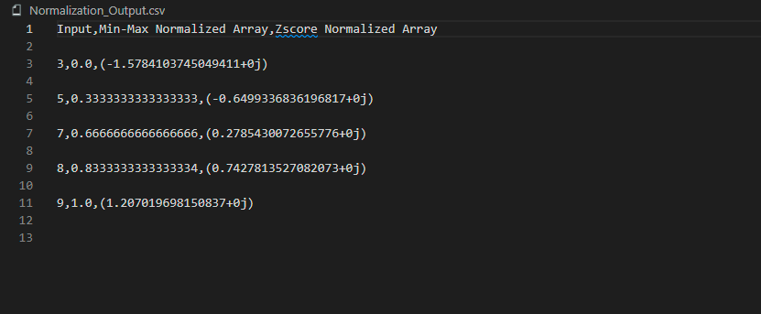

**Conclusion: Successfully performed min-max and z-score normalization with code implementation.**

# Experiment 3. Finding info Gain

**Theory :**

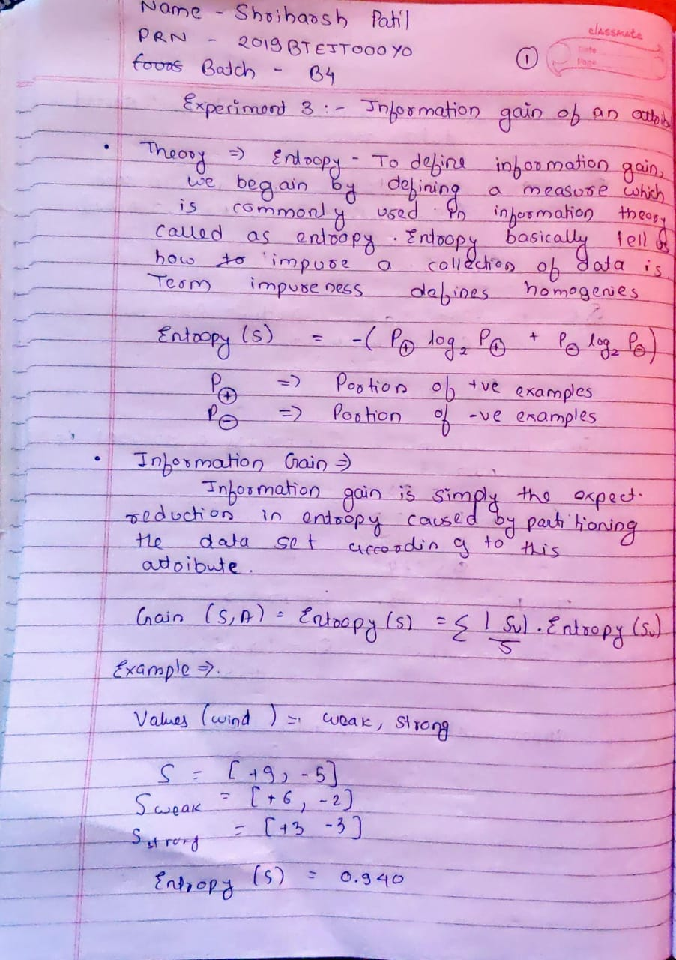

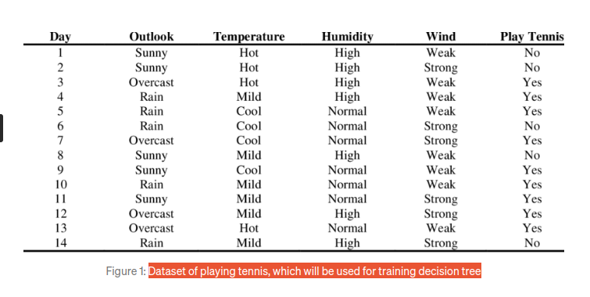

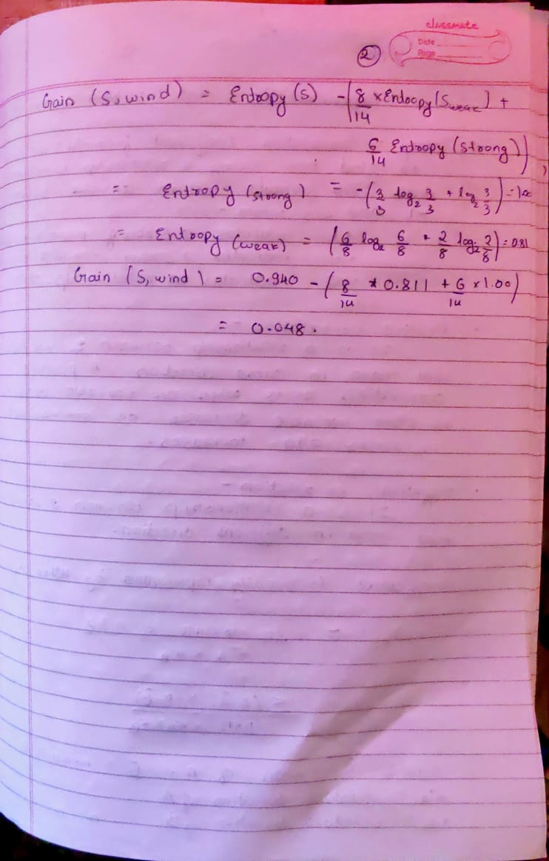

Code :

import numpy as np

import pandas as pd

from sklearn.preprocessing import LabelEncoder

import collections

import math

Le = LabelEncoder()

PlayTennis = pd.read_csv("infogain_input.csv")

def find_entropy(x,y,t):

if x!=0 and y!=0:

return -((x/t)*(math.log2((x/t)))+(y/t)*(math.log2((y/t))))

else:

return 0.0

PlayTennis['outlook'] = Le.fit_transform(PlayTennis['outlook'])

PlayTennis['temp'] = Le.fit_transform(PlayTennis['temp'])

PlayTennis['humidity'] = Le.fit_transform(PlayTennis['humidity'])

PlayTennis['wind'] = Le.fit_transform(PlayTennis['wind'])

PlayTennis['play'] = Le.fit_transform(PlayTennis['play'])

frequencyPlay = collections.Counter(PlayTennis.play)

tot=PlayTennis.play.size

EntropyOfData=find_entropy(frequencyPlay[0],frequencyPlay[1],tot)

print("Total entropy is:"+str(EntropyOfData))

def infoGain(frequncy,a,tot,cond):

infogain = 0.0

for i in frequncy:

cnt = 0

for x in range(PlayTennis.play.size):

if PlayTennis.play.get(x)==1 and a.get(x)==i:

cnt=cnt+1

infogain += (frequncy[i]/tot)*find_entropy(frequncy[i]-cnt,cnt,frequncy[i])

condition = cond

infogain = EntropyOfData - infogain

print("Information gain by {} is: {}" .format(condition,infogain))

frequncyoutlook = collections.Counter(PlayTennis.outlook)

infoGain(frequncyoutlook,PlayTennis.outlook,tot,'outlook')

frequencytemp = collections.Counter(PlayTennis.temp)

infoGain(frequencytemp,PlayTennis.temp,tot,'temp')

frequencyHumidity = collections.Counter(PlayTennis.humidity)

infoGain(frequencyHumidity,PlayTennis.humidity,tot,'humidity')

frequencyWindy = collections.Counter(PlayTennis.wind)

infoGain(frequencyWindy,PlayTennis.wind,tot,'wind')

frequencyPlay = collections.Counter(PlayTennis.play)

infoGain(frequencyPlay,PlayTennis.play,tot,'play')

Output :

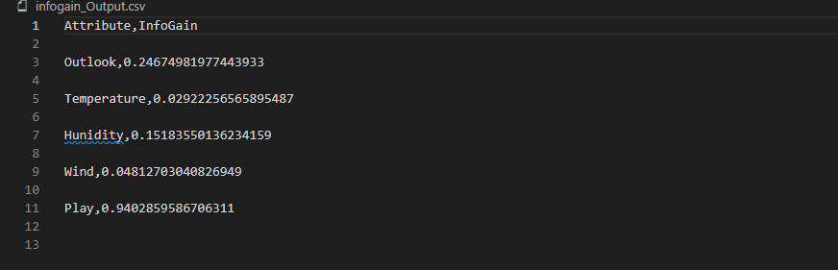

**Experiment 4: Find t and d weight of a data**

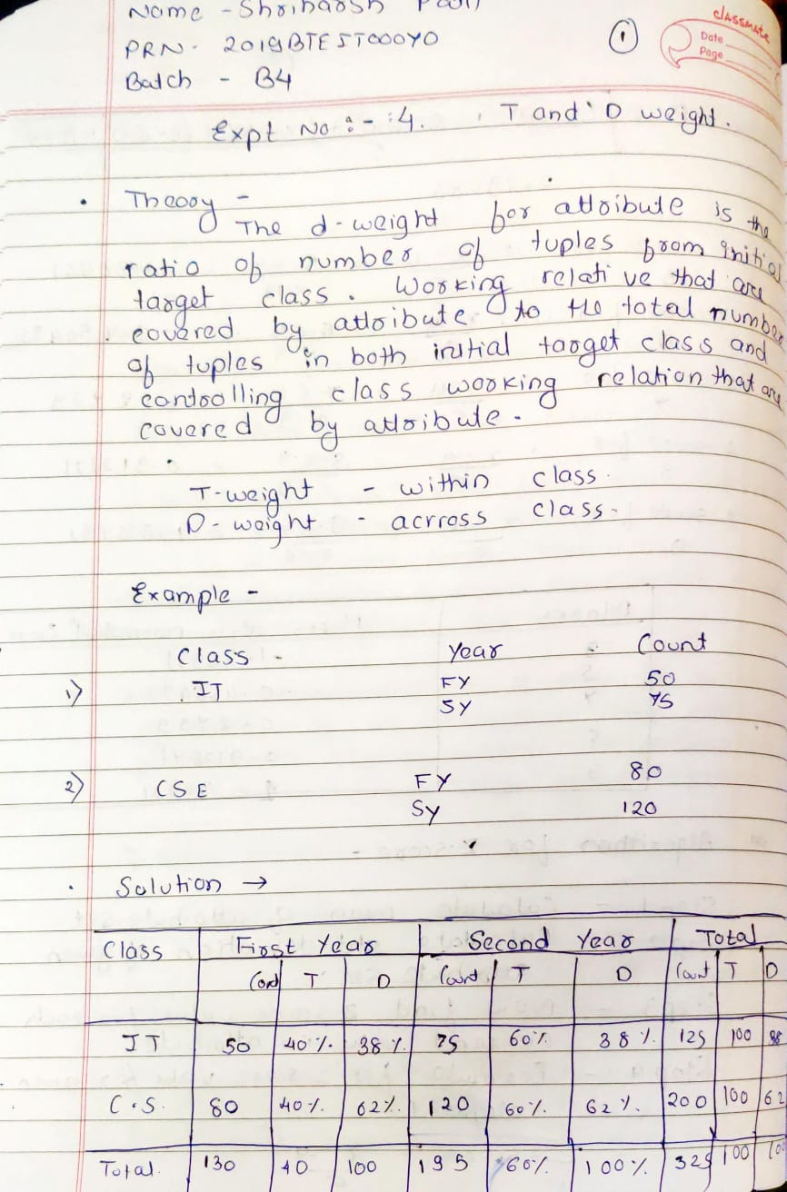

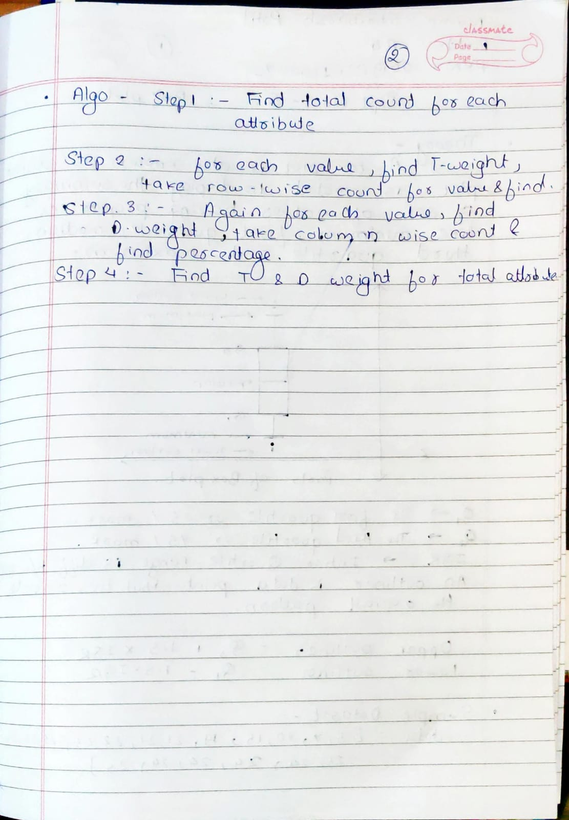

**CODE:**

**import numpy as np**

**import pandas as pd**

**import csv**

**data = pd.read_csv('Tweight_Dweight_Input.csv')**

**Location = data['Location'].tolist()**

**A = data['A'].tolist()**

**B = data['B'].tolist()**

**Total = []**

**for i in range(len(A)):**

**tmp = A[i]+B[i]**

**Total.append(tmp)**

**A_T_wt = []**

**B_T_wt = []**

**A_D_wt = []**

**B_D_wt = []**

**sum_total = sum(Total)**

**for i in range(len(A)):**

**A_T_wt.append(A[i]/Total[i])**

**B_T_wt.append(B[i]/Total[i])**

**A_D_wt.append(A[i]/sum_total)**

**B_D_wt.append(B[i]/sum_total)**

**header = ['Location', 'A', 'B', 'Total' , 'A_T_wt','B_T_wt','A_D_wt','B_D_wt']**

**with open('Tweight_Dweight_Output.csv', 'w', encoding='UTF8') as f:**

**writer = csv.writer(f)**

**# write the header**

**writer.writerow(header)**

**# write the data**

**#writer.writerow(data)**

**for i in range(len(A)):**

**data = [Location[i],A[i],B[i],Total[i],A_T_wt[i],B_T_wt[i],A_D_wt[i],B_D_wt[i]]**

**writer.writerow(data)**

# OUTPUT:

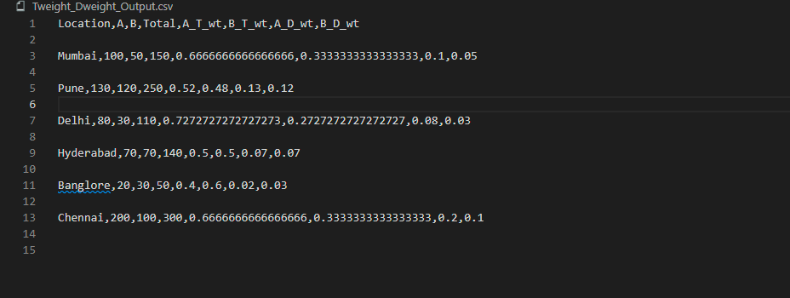

**Conclusion: Successfully performed t and d weight data analysis in data mining from the table in CSV file**

**Expt 5: Find 5 no summary of a dataset (Box Plot)**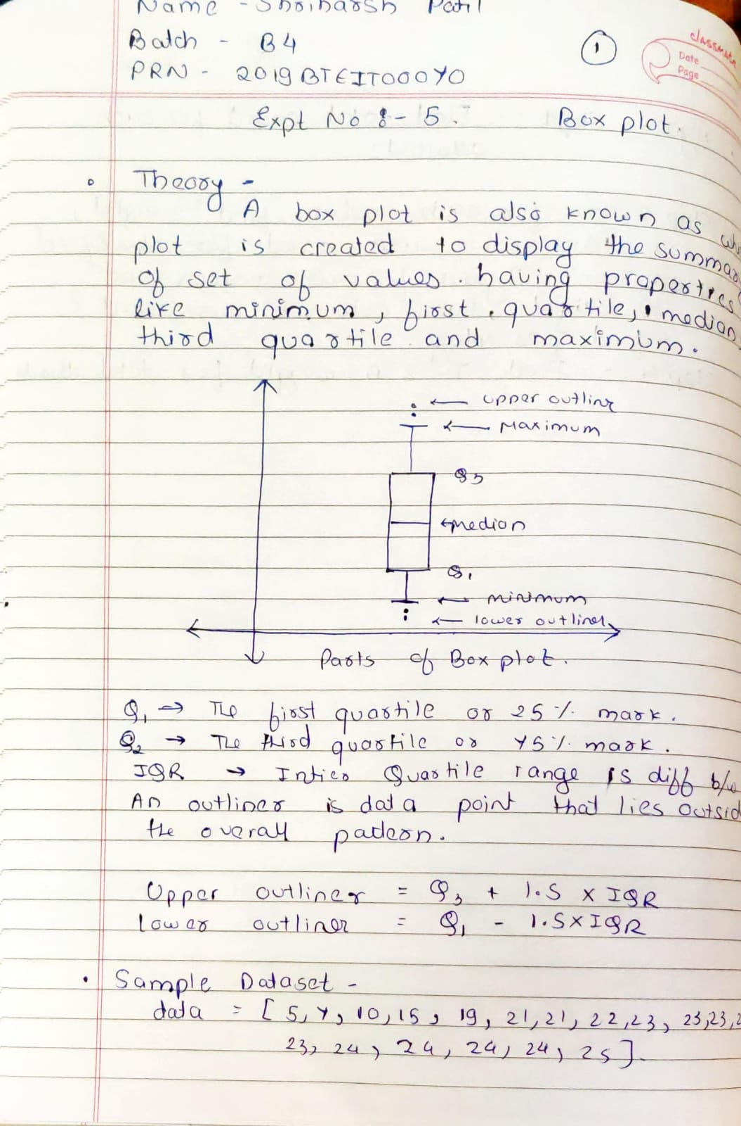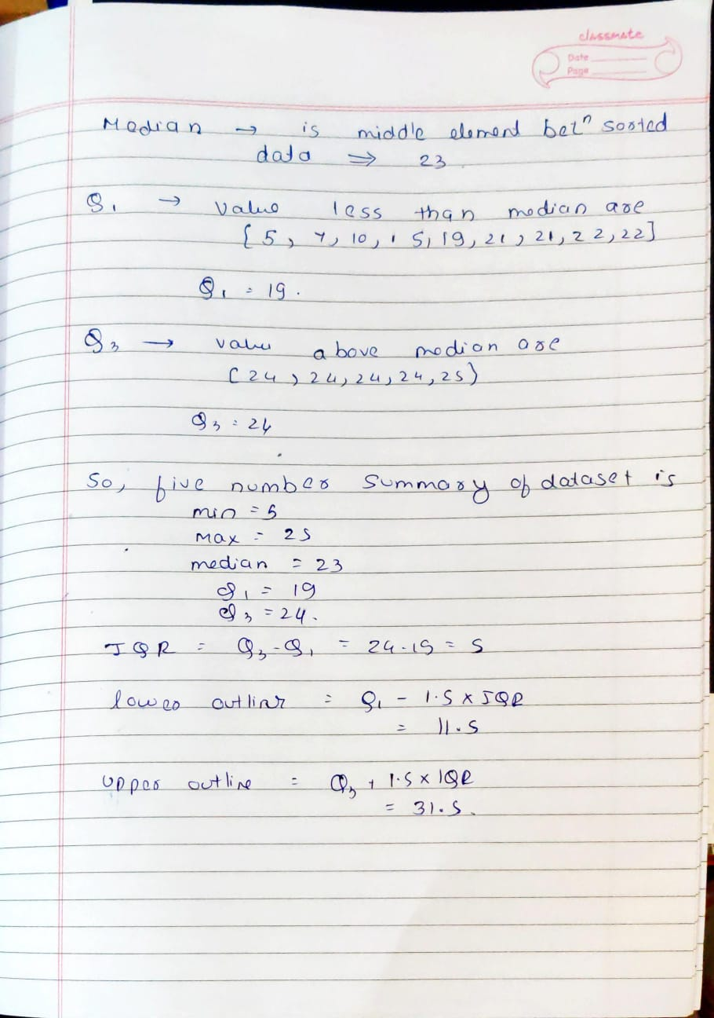

CODE :

import pandas

import csv

import math

data = pandas.read_csv("BoxPlot_Input.csv")

arr = data['A'].tolist()

#sort the Array

arr.sort()

n= len(arr)

Min_val = min(arr)

Max_val = max(arr)

Median_val = arr[(n+1)//2-1]

quartile_1 = arr[(n+1)//4-1]

quartile_3 = arr[3*(n+1)//4-1]

header = ['Min Value', 'Max Value', 'Median','Quartile 1','Quartile 3']

with open('BoxPlot_Output.csv', 'w', encoding='UTF8') as f:

writer = csv.writer(f)

# write the header

writer.writerow(header)

# write the data

data = [Min_val,Max_val,Median_val,quartile_1,quartile_3]

writer.writerow(data)

OUTPUT :

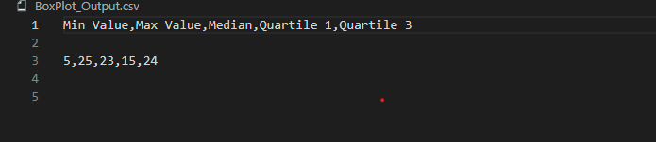

**CONCLUSION :Successfully performed 5 number summary on array of numbers.**

**Experiment 6 : Frequent Item set**

**Theory:**

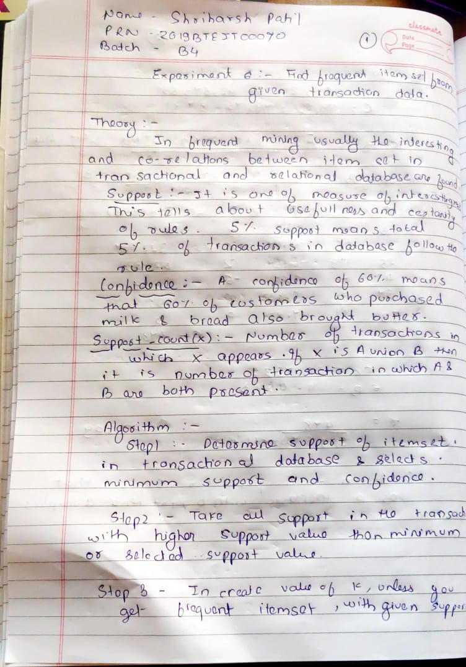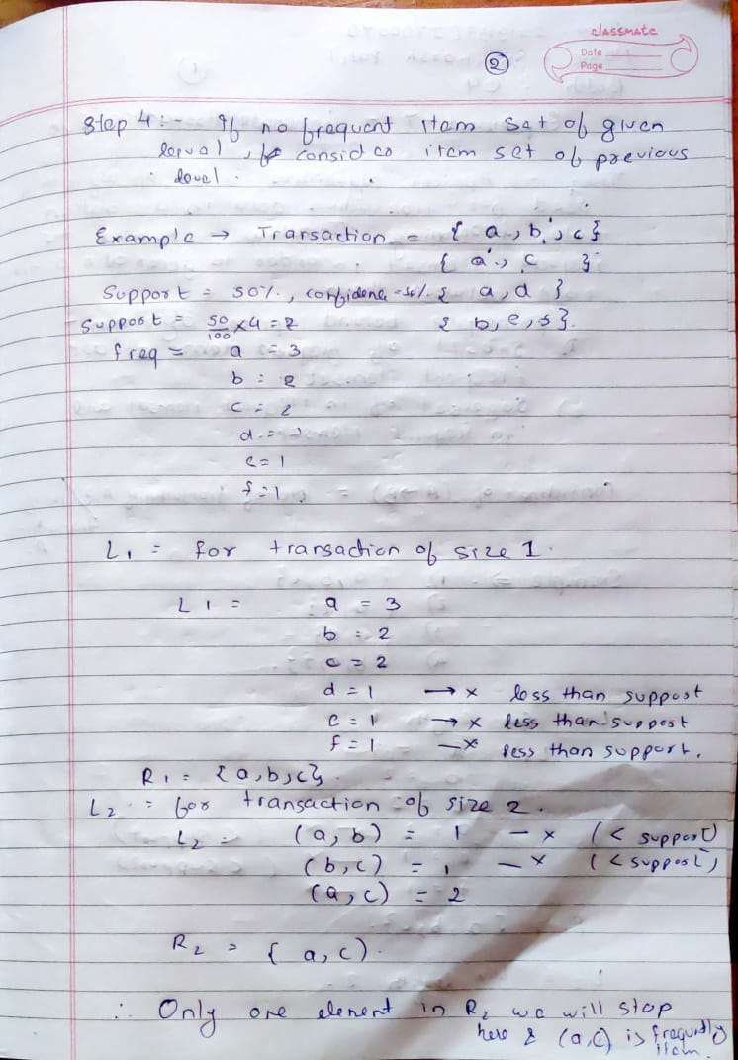

**Code:**

**import math**

**from itertools import combinations**

**def get_freq(s,items,transactions):**

**freq=0**

**for t in transactions:**

**temp=1**

**for item in s:**

**temp*=t[items.index(item)]**

**if temp==1:**

**freq+=1**

**return freq**

**level = 2**

**support = 0.5**

**f = open('FrequentItemSet_input.csv')**

**lines = f.readlines()**

**transactions = []**

**items = lines[0].split(',')**

**for line in lines[1:]:**

**transactions.append(list(map(int,line.split(','))))**

**data ={'items':items,'transactions':transactions}**

**items = data['items']**

**transactions = data['transactions']**

**min_freq = math.ceil(support*len(transactions))**

**sets = list(combinations(items,level))**

**frequent_sets = []**

**for s in sets:**

**freq=get_freq(s,items,transactions)**

**if freq>=min_freq:**

**frequent_sets.append(s)**

**print(frequent_sets)**

**OutPut:**

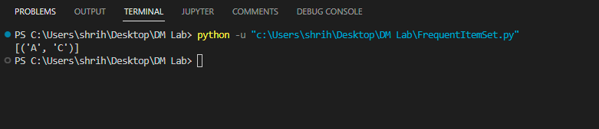

**Conclusion: Successfully calculated frequent itemset of given data set of 4 transactions.**

**Experiment 7 : Generation of Association Rule**

**Theory:**

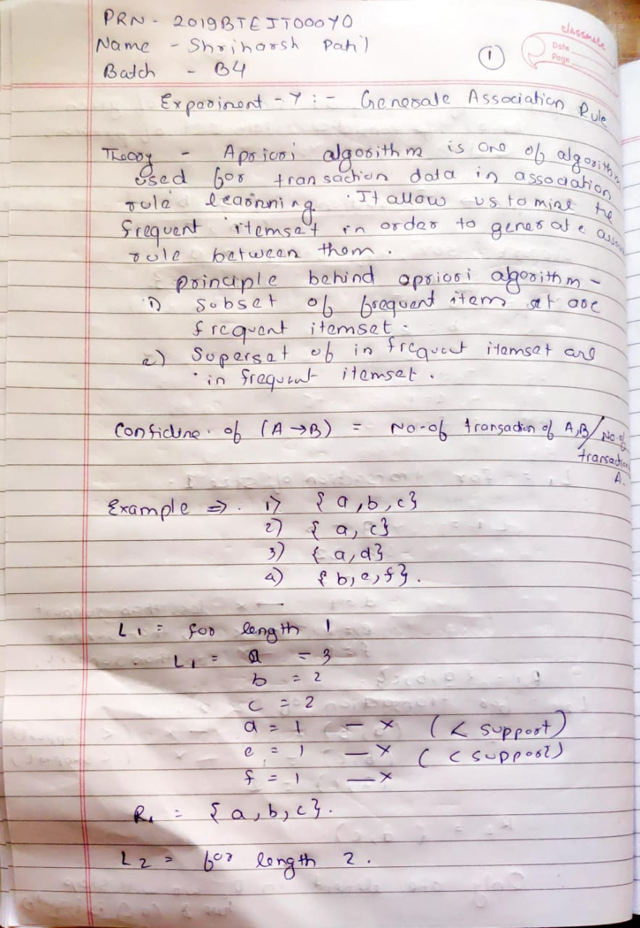

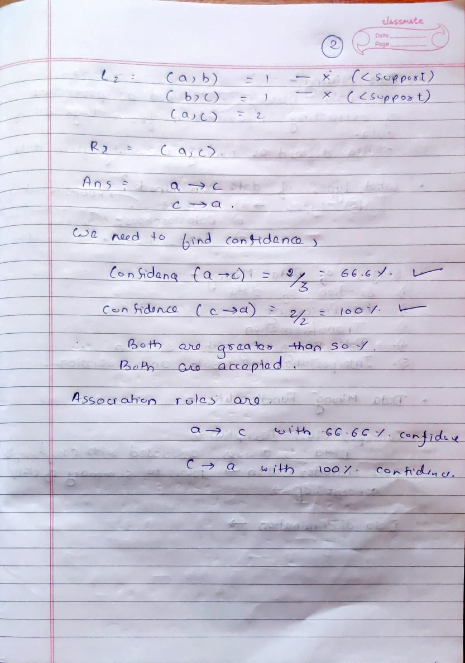

**Code:**

**import math**

**from itertools import combinations**

**from itertools import permutations**

**def read_data_in_dict(filename):**

**f = open(filename)**

**lines = f.readlines()**

**transactions = []**

**items = lines[0].split(',')**

**for line in lines[1:]:**

**transactions.append(list(map(int,line.split(','))))**

**data ={**

**'items':items,**

**'transactions':transactions**

**}**

**return data**

**def frequent_itemsets(data,level,min_support):**

**items = data['items']**

**transactions = data['transactions']**

**min_freq = math.ceil(min_support*len(transactions))**

**sets = list(combinations(items,level))**

**frequent_sets = []**

**for s in sets:**

**freq=get_freq(s,items,transactions)**

**if freq>=min_freq:**

**frequent_sets.append(s)**

**return frequent_sets**

**def get_freq(s,items,transactions):**

**freq=0**

**for t in transactions:**

**temp=1**

**for item in s:**

**temp*=t[items.index(item)]**

**if temp==1:**

**freq+=1**

**return freq**

**def generate_rule(data,min_support,min_confidence):**

**items = data['items']**

**transactions = data['transactions']**

**for l in range(2,len(data['items'])+1):**

**frequent_set = frequent_itemsets(data,l,min_support)**

**for s in frequent_set:**

**freq_s = get_freq(s,items,transactions)**

**_s_permute = list(permutations(s))**

**print(_s_permute)**

**for _s in _s_permute:**

**for i in range(0,len(_s)-1):**

**x = _s[0:i+1]**

**y = _s[i+1:]**

**freq_x = get_freq(x,items,transactions)**

**c = freq_s/freq_x**

**if c >= min_confidence:**

**print(x,' -> ',y,'confidence is ',c)**

**data = read_data_in_dict('Generate_Asscociation_Rule_Input.csv')**

**generate_rule(data,0.5,0.5)**

**OutPut:**

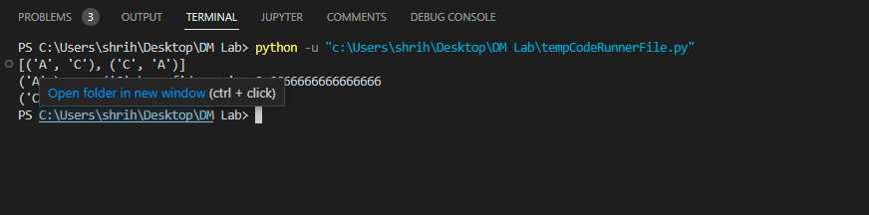

**Conclusion: Successfully derived the association rule itemset of given data set of 4 transactions.**

**Experiment 8 : Find Corelation of 2 Variables**

**Theory:**

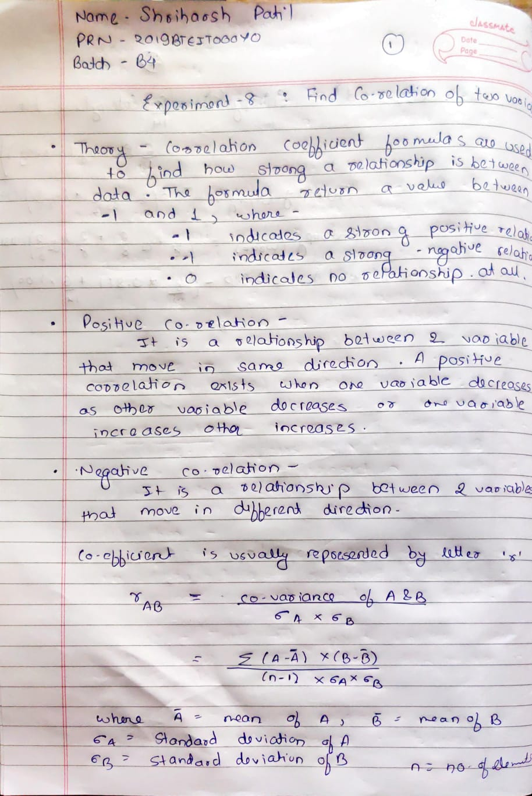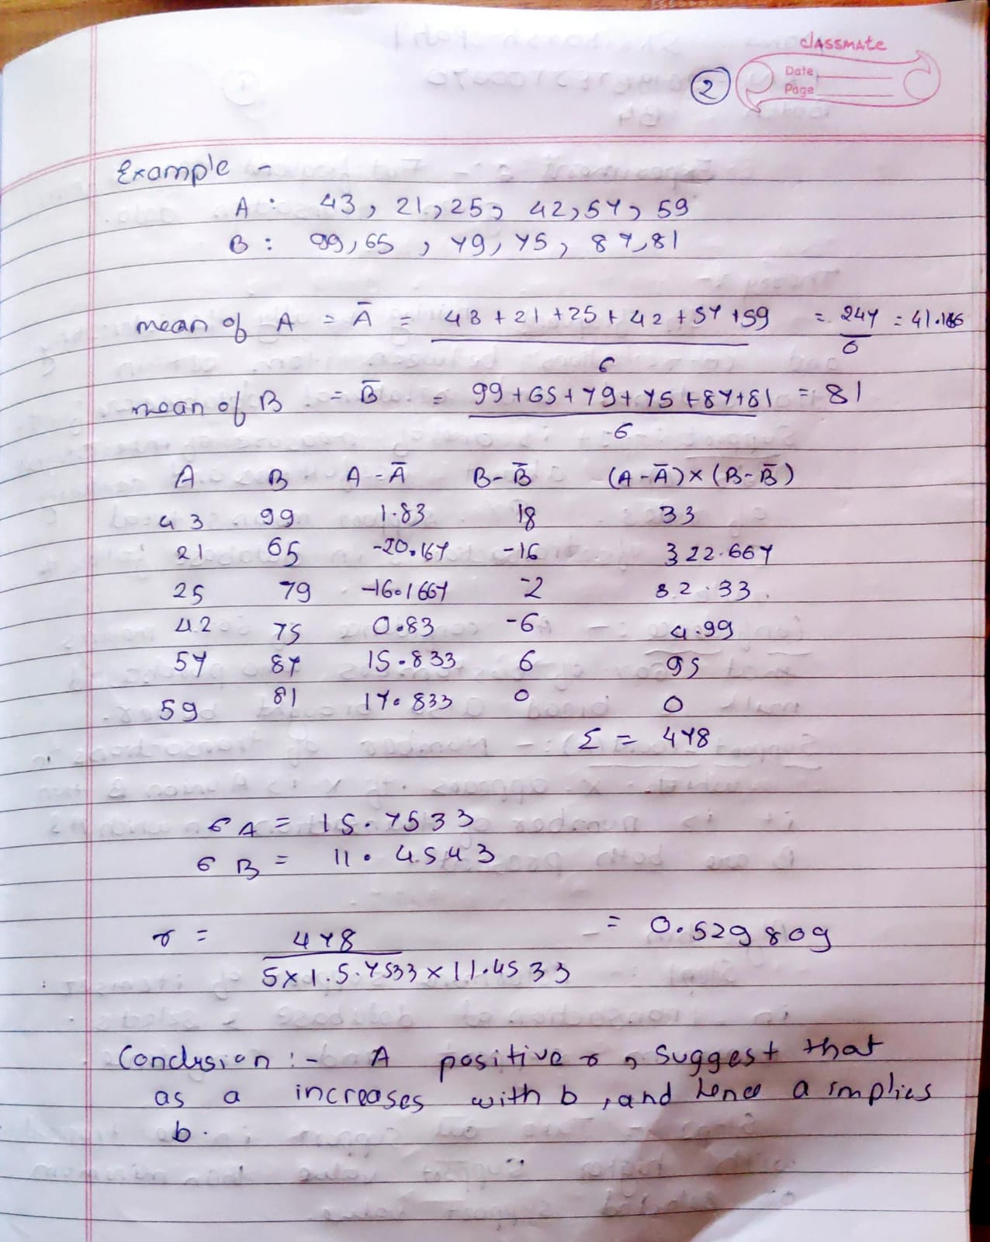

**Code:**

**import statistics as st**

**import pandas as pd**

**import csv**

**Data = pd.read_csv("corelation_input.csv")**

**A = Data['A'].tolist()**

**B = Data['B'].tolist()**

**n = len(A)**

**A_mean = sum(A)/n**

**B_mean = sum(B)/n**

**A_diff = []**

**B_diff = []**

**corelation = []**

**for i in range(len(A)):**

**tmp = A[i] - A_mean**

**A_diff.append(tmp)**

**tmp2 = B[i] - B_mean**

**B_diff.append(tmp2)**

**corelation.append(A_diff[i]*B_diff[i])**

**total_corelation = sum(corelation)**

**stdDevA = st.stdev(A)**

**stdDevB = st.stdev(B)**

**ans = total_corelation/(stdDevA*stdDevB*(n-1))**

**header = ['A', 'B', 'A-a"' , 'B-b"','(A-a")*(B-b")']**

**with open('corelation_Output.csv', 'w', encoding='UTF8') as f:**

**writer = csv.writer(f)**

**# write the header**

**writer.writerow(header)**

**# write the data**

**for i in range(len(A)):**

**data = [A[i],B[i],A_diff[i],B_diff[i],corelation[i]]**

**writer.writerow(data)**

**OutPut:**

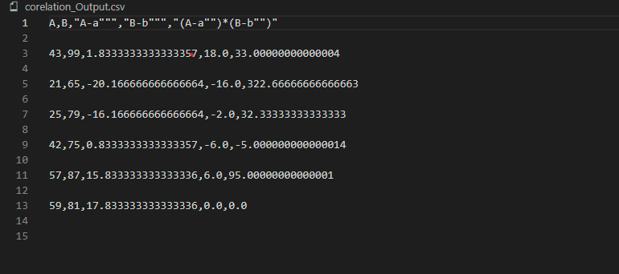

**Conclusion: Successfully calculated the correlation between 2 given dataset and correlation is 0.529**